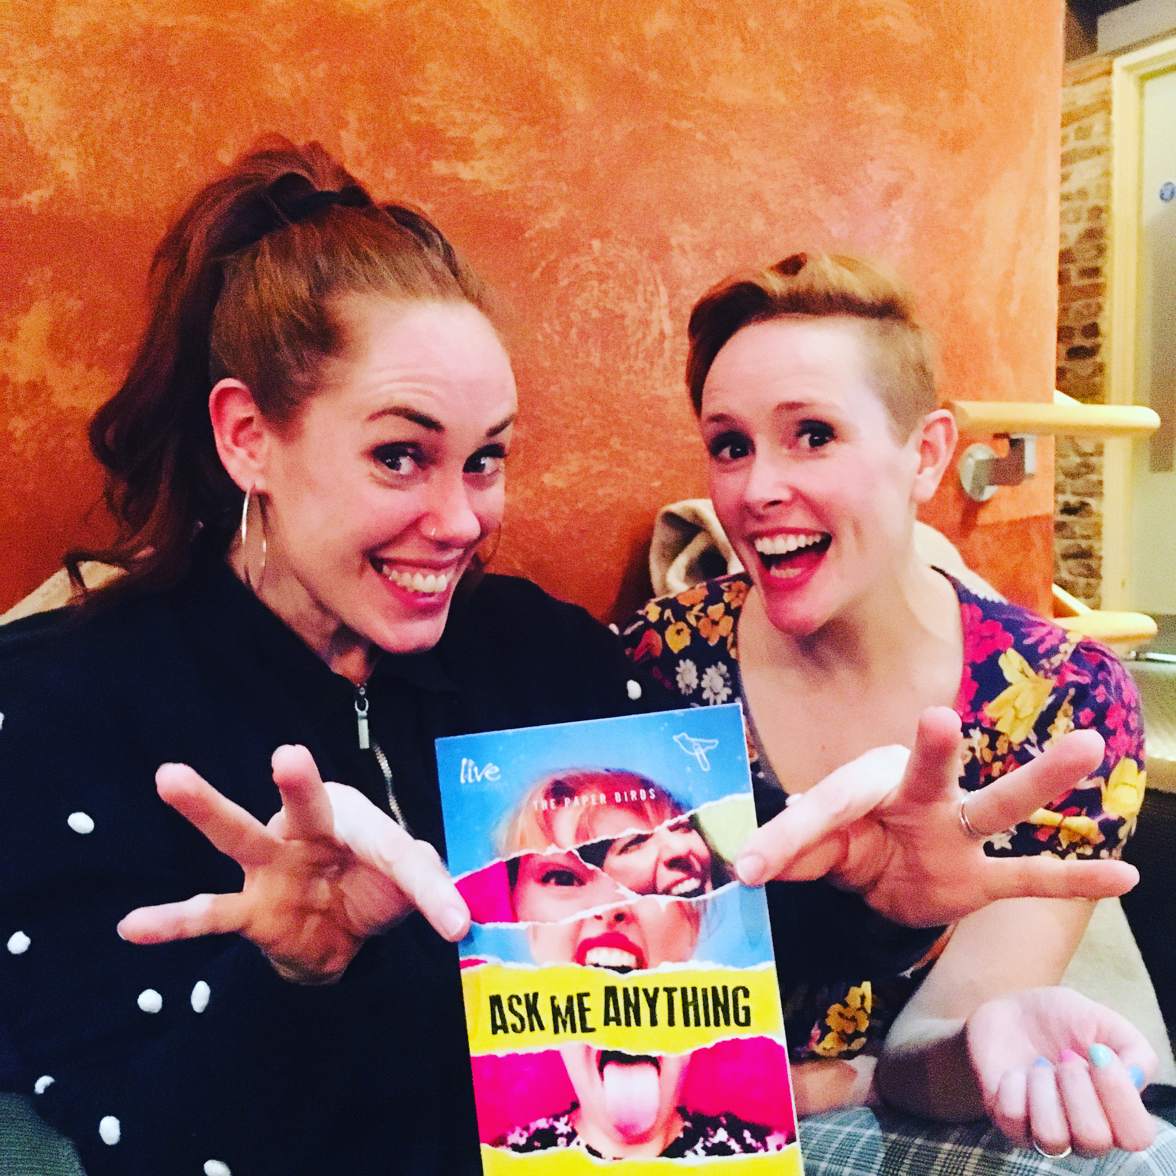

ASK ME ANYTHING PROGRAMME (INCLUDING SCRIPT)
ORDER FORM
Please complete and return via email to katie@thepaperbirds.com
NAME
POSTAL ADDRESS
QUANTITY OF BOOKS
BILLING  (Delete as appropriate) | Please invoice me personally  Please invoice my school
FEE | £9.99 inc VAT per book  Plus £2.50 postage & package per book  TOTAL DUE:
EMAIL ADDRESS TO SEND INVOICE
SCHOOL FINANCE DEPT. EMAIL ADDRESS
PURCHASE ORDER NUMBER FOR INVOICE (If required)

Payment & Returns Policy
Upon submission of this form, an invoice will be raised to you for the full fee. Payment is due within 14 days. Your Theatre Creativity Cards will be sent to you within 5 working days of the receipt of this order form.
Returns cannot be accepted unless in un-opened and re-sellable box. If returned, buyer pays postage back to The Paper Birds

