

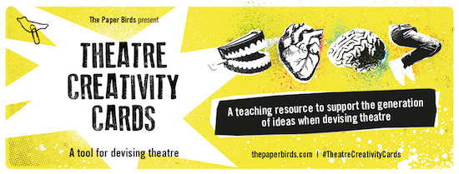

**ORDER FORM**

**Please complete and return via email to** [**education@thepaperbirds.com**](mailto:education@thepaperbirds.com)

|  |  |
| --- | --- |
| **NAME** |  |
| **POSTAL ADDRESS** |  |
| **QUANTITY OF BOXES** |  |
| **BILLING**  **(Delete as appropriate)** | *Please invoice me personally*  *Please invoice my school* |
| **FEE** | £**150.00 inc VAT**  Plus £5.00 postage & packing  **TOTAL DUE: £155.00** |
| **EMAIL ADDRESS TO SEND INVOICE** |  |
| **SCHOOL FINANCE DEPT. EMAIL ADDRESS** |  |
| **PURCHASE ORDER NUMBER FOR INVOICE (If required)** |  |

**Payment & Returns Policy**

***Upon submission of this form, an invoice will be raised to you for the full fee. Payment is due within 14 days. Your Theatre Creativity Cards will be sent to you within 5 working days of the receipt of this order form.***

*Returns cannot be accepted unless in un-opened and re-sellable box. If returned, buyer pays postage back to The Paper Birds*